Experimental study on the extraction of methane hydrate in silica sand by dissolving
Litao Chen¹, Baojiang Sun¹*, Ningtao Zhang¹, Wantian Zhou¹, Haotian Wang¹, Ye Chen¹, Hailong Lu²*
¹ Key Laboratory of Unconventional Oil and Gas Development, Ministry of Education, China University of Petroleum (East China), Qingdao 266580, China
² School of Engineering, Peking University, Beijing 100871, China

Abstract: Natural gas hydrate (NGH) is a type of ice-like compounds formed by natural gas and water at low temperatures and high pressures. As estimated and partially revealed by worldwide geological survey, NGH widely distributes in the sediments of seafloor and permafrost zones. NGH has gained wide attention and become research hotspot due to its potential as an energy reserve. Among the resources, NGH in the shallow layer or directly exposed on the seafloor has been widely discovered, and its formation process and stability law are still unclear. In order to reveal its stability law, the dissolving process of methane hydrate in quartz sand was experimentally studied. The dissolving efficiencies of methane hydrate in silica sand have been studied by injecting water and oil, respectively. The results show that both water and mineral oil can effectively dissolve methane hydrate in quartz sand, with the gas-to-liquid volume ratio about 2 for water injection and about 10 for oil injection. The cumulative gas production of water dissolving generally increases logarithmically with time, and the gas production rate fluctuates greatly, but it decreases gradually as a whole, and the gas-liquid ratio is stable at first and then decreases gradually; the cumulative gas production of oil dissolving generally increases in S shape with time, and the gas-liquid ratio increases first and then decreases gradually. At the same injection rate, the gas production rate and gas-liquid ratio of oil dissolving are significantly higher than those of water dissolution. The dissolving rate of hydrate is mainly affected by the type of dissolving medium (water or oil, in this work) and the contact status between dissolving medium and hydrate. Water and oil are easily channeled into quartz sand, forming a dominant seepage channel. The gas-to-liquid ratio decreases when water/oil forms dominant seepage channel. The results provide theoretical basis for stability studies of NGH in the shallow layer or directly exposed on the seafloor. It seems feasible in principle to exploit gas hydrate in the shallow layer or exposed to the sea floor by dissolving. It is suggested that systematic experimental and numerical simulation studies should be continued in the future.
Keywords: methane; hydrate; dissolving; silica sand; experiment
1. Introduction
The world energy structure is shifting to low-carbon, and the proportion of natural gas in global energy consumption is increasing year by year. It is predicted that natural gas will surpass coal and oil and become the single-type fossil energy with the highest proportion after 2030^{[1]}. Natural gas hydrate (combustible ice) is an ice-like substance formed by natural gas and water under low temperature and high pressure conditions^{[2]}. It is widely distributed in nature and is an unconventional natural gas resource^{[3]}. According to preliminary estimates, it is generally believed that the natural gas resource in the global natural gas hydrate is about 2×1016 m (standard condition), and its carbon equivalent is about twice the sum of 3 conventional fossil energy. The resource is huge, and it is expected to become a replacement energy in the future^{[4]}. The global natural gas hydrate resources are mainly distributed in the sediments of continental slopes and permafrost in the sea area, of which the sea area natural gas hydrate accounts for about 98%^{[5]}. Therefore, the exploration and development of marine gas hydrates are highly valued by countries all over the world.
……
2. Experimental section
2.1. Materials
The materials and reagents used in the experiment are shown in Table 1.
2.2. Apparatus
The composition of the experimental system is shown in Figure 3. The system is mainly composed of a sand filling reactor, a constant speed and constant pressure pump, a back pressure valve and a gas-liquid recovery measuring device, etc. It can be used for the formation and dissolution experiment of gas hydrate in quartz sand. The maximum working pressure is 20 MPa and the working temperature is -5~30℃. The size of the sample tube in the sand filling reactor is Φ22 mm×320mm. The inlet end is connected to the liquid and gas supply pipelines, and the outlet end is provided with a layer of 600 mesh (0.02 mm) sand control net, which is connected to the back pressure valve and the gas-liquid recovery measuring device. The maximum flow rate of the constant-speed and constant-pressure pump is 25 ml/min, and the maximum pump pressure is 20 MPa. Two modes of constant flow or constant pressure can be selected as required. Pre-cool the injected liquid with the coil and the ice-water mixture.
2.3. Experimental steps
The experiment is divided into two parts: formation and dissolution. The hydrate is formed first, and then the dissolution experiment is carried out. Generating an experiment includes the following steps:
(1) Use deionized water to clean the reaction vessel (including sample tube) and quartz sand 3 times, dry it, fill the sample tube (V = 106 ml) with quartz sand, seal it, and check the air tightness;
..….
Using the above steps, all gases can be converted into hydrates, and hydrate samples without free gas can be prepared. The pressure of injected methane is calculated by formula (1):
$P= \frac{ZnRT}{V}$ (1)
Among them, the compressibility factor Z is calculated by the PR equation of state; T is the room temperature; n is calculated by the formula (2):
$n= \frac{V_{P}S}{V_{hm}}$ (2)
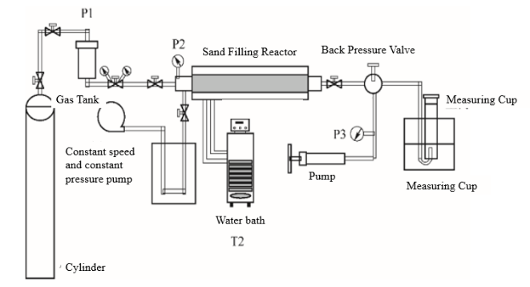

Fig. 1. Schematic of the apparatus for gas hydrate dissolving experiment
3. Experimental results and discussion
A total of 5 groups of experiments were carried out, of which 3 groups were dissolved by water injection, and the hydrate saturation was 10%, 20%, and 30% (nominal saturation) respectively; the other 2 groups were dissolved by oil injection, and the hydrate saturation was 10% respectively. And 20%. The experiment and output are shown in Table 2.
Table 1. Materials used in the experiments
Name. | Specification | Manufacturer
Deionized water | 18.2 MΩ·cm | Lab homemade  Tongzhou Hongren Gas Co., Ltd.  Heyuan Wanchuan Quartz Development Co., Ltd.  Mojiezuo Petrochemical (Shanghai) Co., Ltd.  Aladdin Chemical Reagent Co., Ltd.
CH4 | 99.9%
Quartz sand | 400~1200μm
Mineral white oil | 5#
Span80 | 99.0%
3.1. Gas and liquid production
Figures 4 and 5 show the cumulative gas and liquid production curves of reservoirs with different hydrate saturations during water injection and oil injection dissolution. It can be seen from the figure that both water injection and oil injection can effectively dissolve hydrates..
3.2. Gas-liquid ratio change
After the methane-dissolved fluid reaches the outlet, it enters the measuring cylinder under normal temperature and pressure conditions, where methane gas is rapidly precipitated. At this time, the ratio of gas production volume to liquid production volume is called the gas-liquid ratio. Figures 7 and 8 show the gas-liquid ratio curves of water and oil injection to dissolve hydrate reservoirs with different saturations, respectively. Among them, the instantaneous gas-liquid ratio is the volume ratio of the gas production to the liquid production between two adjacent data points,

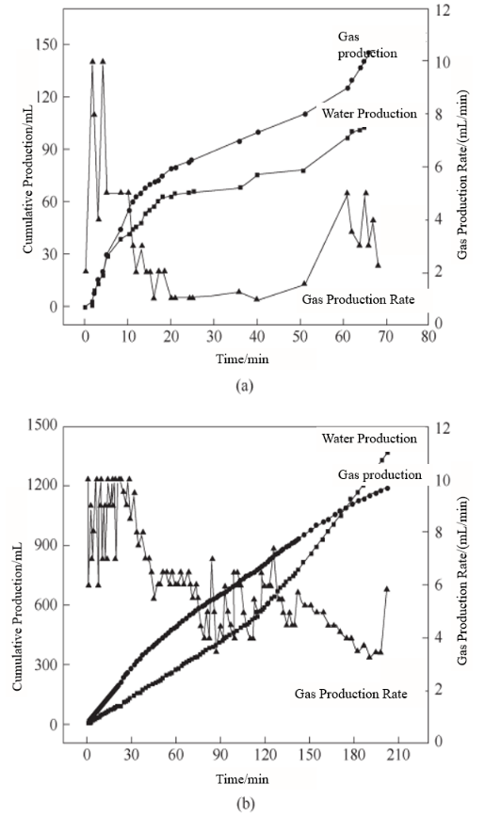

Fig. 4. Gas and water production profile in water dissolving from methane hydrate formation with different saturations(a) nominal hydrate saturation 10%; (b) nominal hydrate saturation 20%
and the cumulative gas-liquid ratio is the volume ratio of the cumulative gas production to the cumulative liquid production at a certain moment. As can be seen from the figure, when the water is injected to dissolve, the change of gas-water ratio can be divided into three stages: the initial abnormally high gas-water ratio stage, the medium-term stable gas-liquid ratio stage, and the later gas-water ratio gradually decreasing stage; When dissolving, the change of gas-liquid ratio can be divided into three stages, the initial stage of gas-liquid ratio increase, the middle stage of steady gas-liquid ratio, and the later stage of decrease. Analysis suggests that the gas-liquid ratio is mainly affected by the type of fluid injected, injection rate, and hydrate saturation, and the highest value should correspond to its solubility. Because a small amount of methane gas remained in the joint at the outer end of the reactor during the generation process, or part of the methane gas was collected in the production pipeline joint during the dissolution process, the gas-liquid ratio in the experiment appeared abnormally high.
……
4. Conclusion
Under the experimental conditions in this paper, both deionized water and mineral white oil can effectively dissolve methane hydrate in quartz sand. The gas-liquid volume ratios of the initial produced fluids for water dissolution and oil dissolution are about 2 and 10, respectively. The cumulative gas production of water dissolving grows roughly logarithmically with time, the gas production rate fluctuates greatly but the overall gas-liquid ratio is basically stable and then gradually decreases; the cumulative gas production of oil dissolving grows in an S-shaped manner with time , The gas production rate fluctuates greatly as a whole, first increases and then gradually decreases, and the gas-liquid ratio first increases and then gradually decreases. At the same injection rate, the gas production rate and gas-liquid ratio of oil dissolution are significantly higher than that of water dissolution. The dissolution rate of hydrate is mainly affected by the type of dissolving medium and the contact between dissolving medium and hydrate. Water and oil are easy to penetrate in the quartz sand, forming a dominant seepage channel. It is feasible in principle to dissolve and extract natural gas hydrates in shallow layers or exposed on the seabed. It is recommended to continue systematic experiments and numerical simulation studies.
Acknowledgement
The authors would like to appreciate…..
Symbol Description
H—Hydrate
T—Temperature
……
Reference
- British Petroleum. Energy outlook 2020 edition[R]. London: BP, 2020.
- Sloan E D, Koa C A. Clathrate Hydrates of Natural Gases[M]. 3rd ed. Boca Raton, FL: CRC Press, 2007.
- Boswell R, Collett T S. Current perspectives on gas hydrate resources[J]. Energy Environ. Sci., 2011, 4(4): 1206-1215.
- Chen L T. Study on the formation conditions and kinetic behavior of gas hydrate in porous media[D]. Beijing: China University of Petroleum (Beijing), 2011.
- Chen L T, Zhou W T, Zhang N T, et al. Methods of gas hydrate exploitation: 201910108515.6[P]. 2020-04-17.
- ……

* Corresponding author. Prof. Sun Baojiang, E-mail: sunbj1128@vip.126.com
Prof. Lu Hailong, E-mail: hlu@pku.edu.cn

